

Lab particale-4H

1)Develop a system using UML for Recruitment System, to recruit the applicant for a particular job in the company. It was controlled by the
central management system to manage the details of the particular applicant who has to be recruited by a company.

AIM: To draw an UML diagrams for Recruiting System to recruit the applicant for particular job using Umbrello software.

USE CASE:

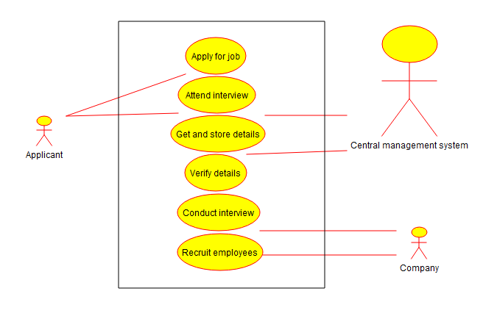

CLASS DIAGRAM:
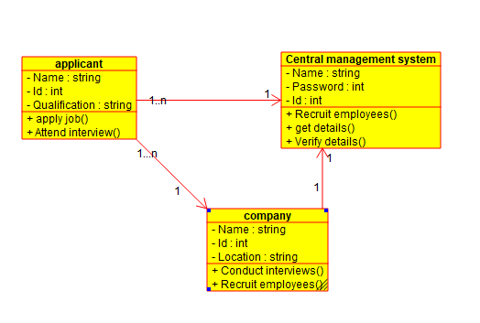

ACTIVITY DIAGRAM:

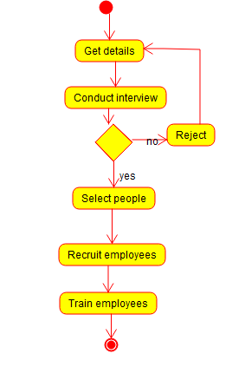

COMPONENT DIAGRAM:

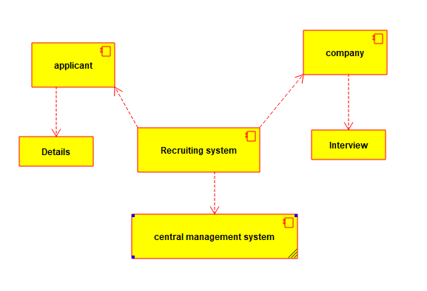

STATE CHART DIAGRAM:

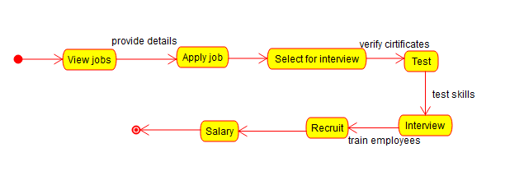

SEQUENCE DIAGRAM:

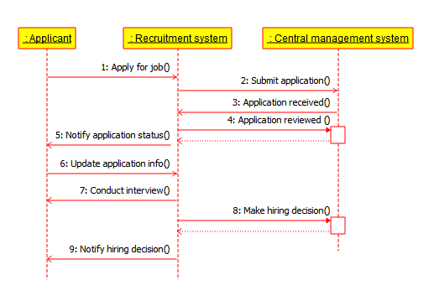

DEPLOYMENT DIAGRAM:

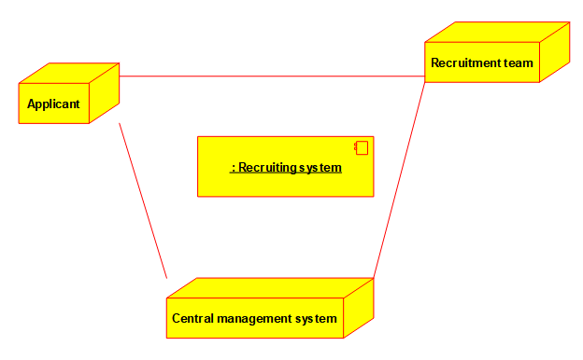

COMMUNICATION DIAGRAM:

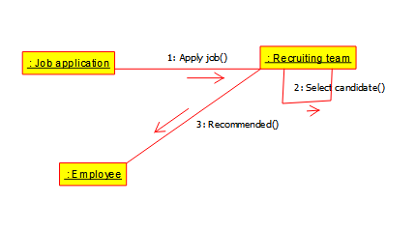

ENTITY RELATIONSHIP DIAGRAM:
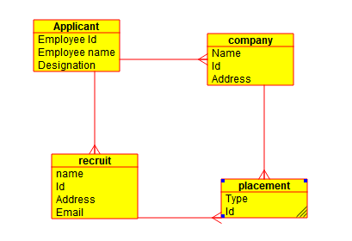

RESULT: Thus the UML diagrams for Job Recruiting system has been drawn successfully by using Umbrello Software.

2)Develop a system using UML for Library Management System. It should verify the details of the reader by the central computer. The details regarding the reader will be provided to the central computer through the administrator in the library and the computer will verify the details of the reader and provide approval to the office. Then the books that are needed by the reader will issue from the library to him.

AIM: To draw an UML diagrams for Library Management System using Umbrello software.

USE CASE:

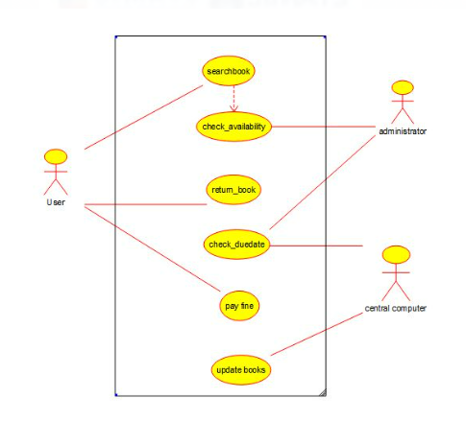
CLASS DIAGRAM:
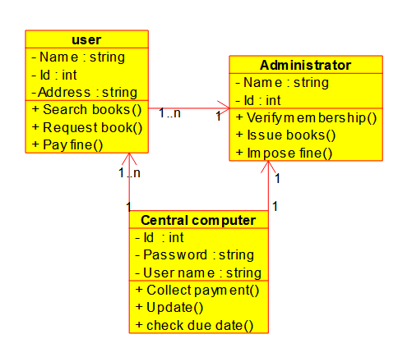
ACTIVITY DIAGRAM:

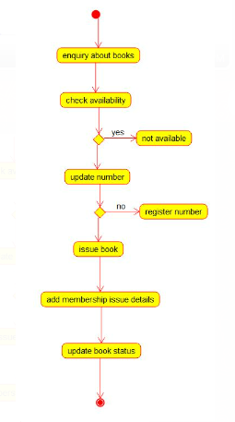

STATE CHART DIAGRAM:

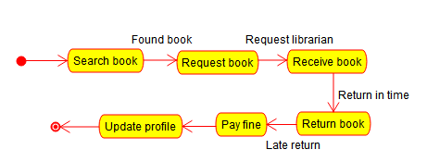

DEPLOYMENT DIAGRAM:

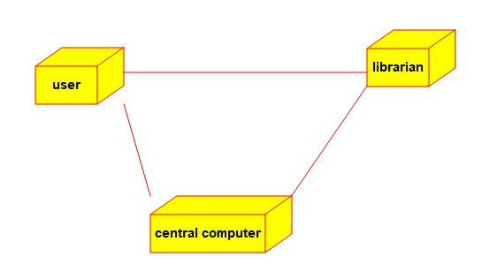

COMPONENT DIAGRAM:

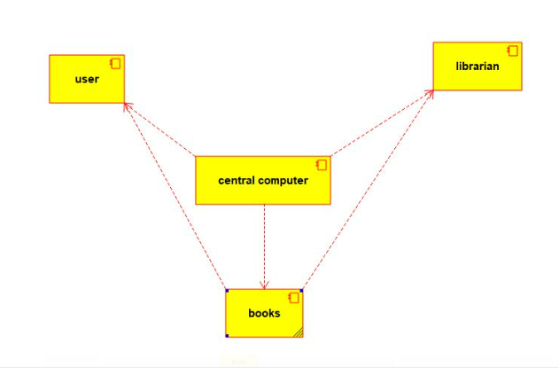

SEQUENCE DIAGRAM:

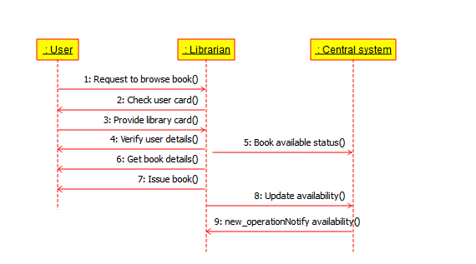

COMMUNICATION DIAGRAM:

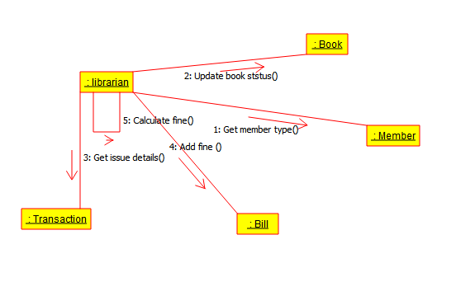

ENTITY RELATIONSHIP DIAGRAM:
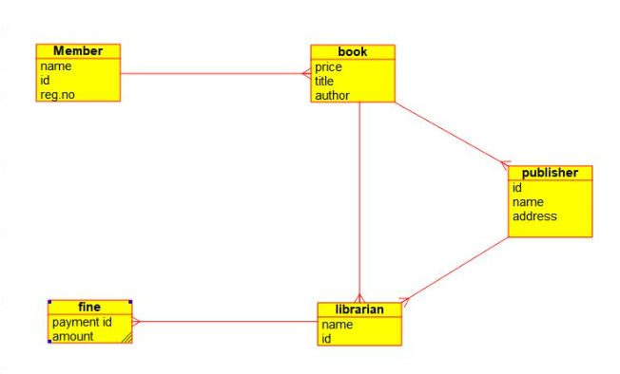

RESULT: Thus the UML diagrams for Library Management System has been drawn successfully by using umbrello software.

3)Develop a system using UML for Blood Bank Registration System. The system should have the list of donors and the hospitals can check for the donor's availability and get their appointment. The donor and the hospital can interact with the central system

AIM: To draw an UML diagrams for Blood Bank System by using Umbrello Software.

USE CASE:
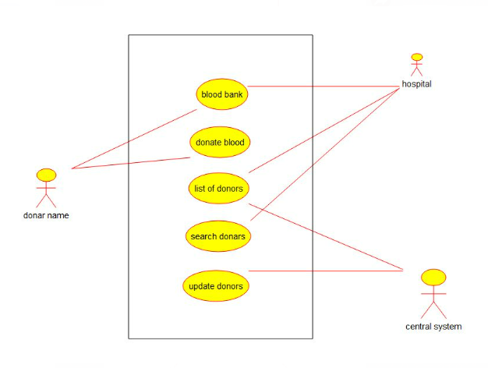

CLASS DIAGRAM:
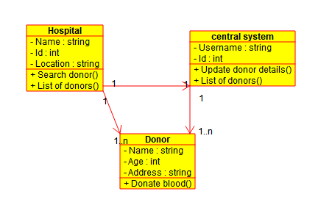

ACTIVITY DIAGRAM:
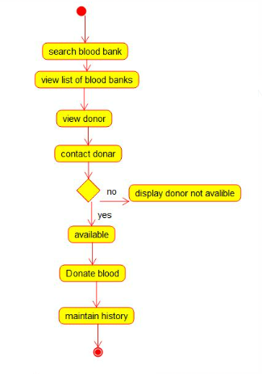

STATE CHART DIAGRAM:
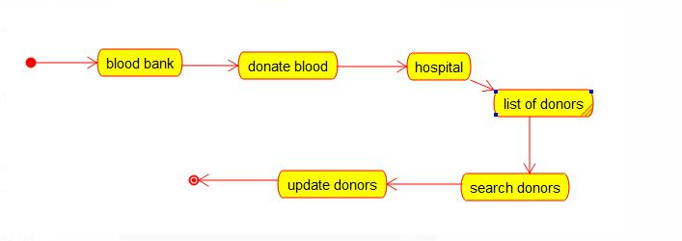

SEQUENCE DIAGRAM:
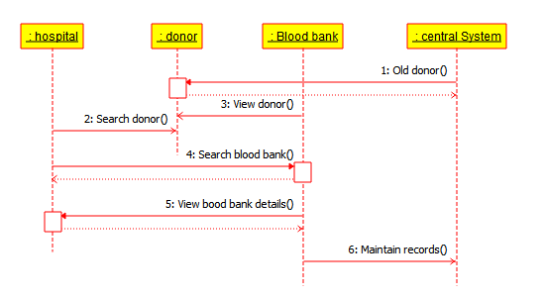
COMPONENT DIAGRAM:
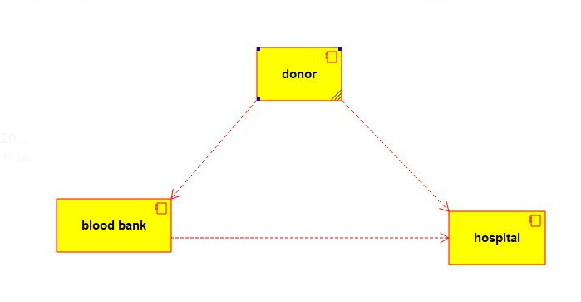

DEPLOYMENT DIAGRAM:
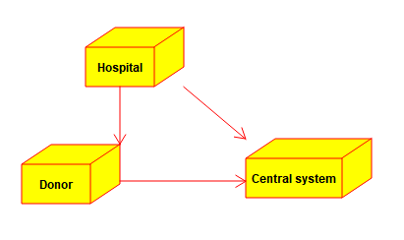

COMMUNICATION DIAGRAM:
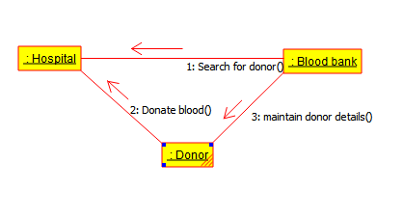

ENTITY RELATIONSHIP DIAGRAM:
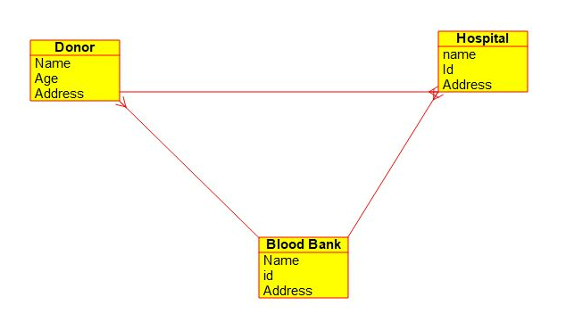

RESULT: Thus the UML diagrams for Blood Bank Management system has been drawn successfully by using Umbrello Software.

